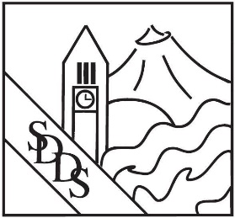
SDDS/ EWU Hygiene Mixer
February 26th, 6:00-9:00PM ~ Ruby River Hotel, Spokane
Sponsorship Options:
Gi Gift Basket Sponsor: $250 Includes your business card/flyer. Basket items will be procured and assembled by SDDS and raffled off to an EWU student. **Or assemble your own gift basket and deliver to SDDS office by February 20th
Beverage Sponsor: $1,200 Includes signage with your logo at the bar, spoken acknowledgement at the event, admission for up to 3 representatives from your organization, and acknowledgement in all digital marketing material associated with the reception.
Advertising Sponsor: $200 (6 available) Includes your logo/weblink in all digital invitations and marketing for the event, acknowledgement as a sponsor announced verbally and on signage at the event
Event Ticket: $150 Don’t miss your opportunity to network with Spokane area dentists and soon-to-be hygienists! Includes admission, appetizers and 2 drink tickets

Contact Name _______________________________________________
Title _______________________________________________
Organization _______________________________________________
Address _______________________________________________ City ____________________State ______Zip __________ Phone ________________________________ Fax___________________________________
Email _______________________________________________
Total Amount:_$___________________________
Payment Method: ______Check Enclosed ______
Credit Card # (Visa, MasterCard, AMEX)
__________________________________________________________ CVS # __________
Expiration Date: _______________________ Billing Zip Code: ______________
Signature: _________________________________________________________

Please complete this form and return it along with your payment to:
Lacy McCormick, Spokane District Dental Society
23403 E Mission Ave, Suite 104, Liberty Lake, WA 99019
509-838-5040 Fax

