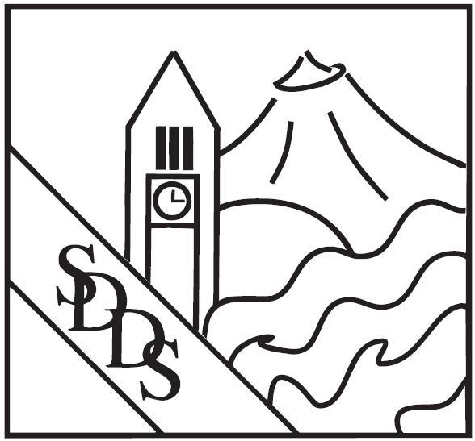

Spokane District Dental Society
2025–2026 Sponsor & Advertising Menu

Membership / CE Dinner Meeting Sponsor
$495 + $100 door prize donation
• Admission, dinner, and networking for up to two representatives
• Display table in meeting room
• Recognition in all marketing and registration materials related to the meeting
*Up to four sponsors per meeting.*

Virtual Meeting Sponsor
$350
- A 5-minute pre-recorded video (company overview, product highlight, or message) played for the full meeting audience during the program
- One printed flyer or promo sheet placed at each attendee’s table setting
- Recognition on event signage and verbal acknowledgment during the meeting

Exclusive E-Blast
$350 each
• One-page flyer (client-designed) with optional weblink
• Sent directly to the SDDS member email list (one-time distribution)

E-Newsletter Sponsor
$200 each or $1,500 annually
• 460 × 60 banner ad (client-designed) including your website link
• Featured at the bottom of the SDDS monthly E-Newsletter distributed to all members
*Multiple sponsors per issue.*

Newsletter Flyer Inserts
$400 each or $1,200 annually
• Full-color 8.5″ × 11″ flyer (client-designed) inserted into the quarterly printed SDDS newsletter
• Distributed by mail to all members
*Printing and insert fees included.*

Classified Advertising
$75 per listing
• Text-only ad, up to 30 words
• Published in the quarterly newsletter, monthly E-Newsletter, and posted on the SDDS website for 90 days

INDC (Inland Northwest Dental Conference)
Sponsor or exhibit at the 34th Annual INDC, April 30–May 1, 2026 at The Davenport Grand Hotel.
*Registration opens soon at www.indc-spokane.com.*

Speaker Sponsor
Partner with SDDS to support an educational CE speaker or Key Opinion Leader at a future meeting.
*Contact SDDS for details and availability.*

Preferred Vendor Directory Listing
$350 per year
• Featured on the SDDS website “Preferred Vendors” page
• Alphabetical company listing with contact info, brief description, and logo linked to your website
• Great for vendors seeking year-round visibility among local dental professionals

Homepage Scrolling Banner Ad
$525 per year (includes Directory Listing)
• Company name and logo displayed in the scrolling banner at the bottom of the SDDS homepage
• Linked directly to your company website
• Maximum size: 230 px × 100 px
• Includes complimentary listing in the Preferred Vendor Directory

Have questions or want to reserve a sponsorship? Contact Lacy McCormick, Executive Director at info@spokanedentalsociety.org or (509)838-0436

